L 10 : probabilities (Part I)

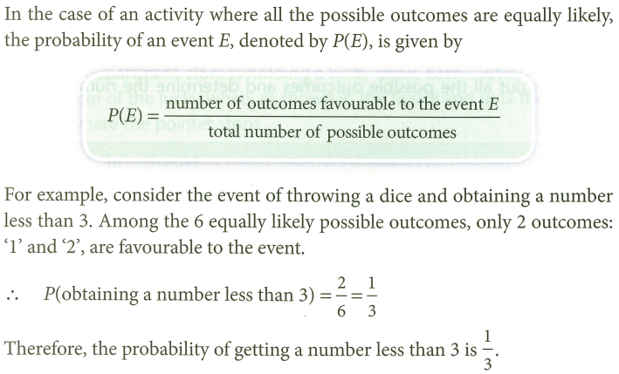
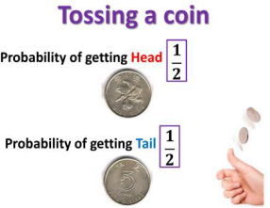

1. ‘PNEUMONOULTRAMICROSCOPICSILICOVOLCANOCONIOSIS’ is a $45$-letter word known as the longest word published in a major English dictionary. A letter is chosen at random from this word. Given that there are $9$ ‘O’s in the word, find the probability of getting an ‘$O$’.

2. A letter is chosen at random from the word ‘WONDERLAND’. Find the probabilities of getting
(a) a ‘$D$’,
(b) a vowel (響音).

3. If a letter is chosen at random from the word ‘MATHEMATICS’, find the probabilities of getting
(a) a ‘$T$’,
(b) an ‘$R$’.

4. A dice is thrown. Find the probabilities of getting
(a) the number ‘$2$’ or ‘$5$’,
(b) an even number.

5. If a dice is thrown, find the probabilities of getting a number which is
(a) greater than $3$,
(b) equal to $8$,
(c) less than $7$.

6. A dice is thrown. Find the probabilities of getting
(a) an even number smaller than $4$,
(b) an even number or a number smaller than$4$.

7. An integer is chosen at random between $1$ and $30$ inclusive. Find the probabilities that the integer is
(a) a multiple of $6$,
(b) between $2$ and $22$ inclusive.

8. David selects a number at random from all positive $2$-digit integers. Find the probabilities of getting
(a) a number divisible by $3$,
(b) a number divisible by $5$,
(c) a number divisible by both$3$ and $5$.

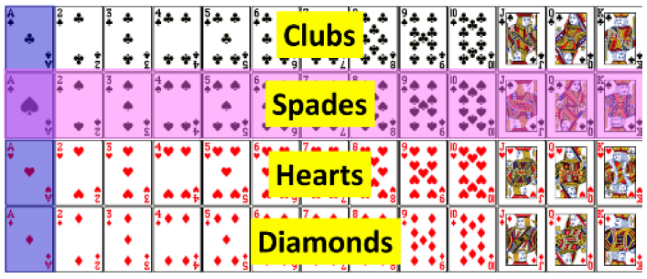
9. A card is drawn at random from a pack of
$52$ playing cards. Find the probabilities of
getting
(a) a ‘$J$’,
(b) the Ace of diamonds.

10. A card is drawn at random from a deck of $52$ playing cards. Find the probabilities of drawing
(a) an Ace or an ‘$8$’,
(b) a black face card,
(c) a diamond or a ‘$K$’.

11. A card is drawn randomly from a deck of $52$ playing cards. Find the probabilities that the card drawn is
(a) an Ace or a face card,
(b) not a spade or a ‘$K$’.

12. A bag contains $k$ green beans and $8$ red beans. If a bean is randomly drawn from the bag, the probability of drawing a red bean is $\frac{2}{7}$. Find the value of $k$.

13. There are $33$ male staff and $n$ female staff in a company. If a staff is randomly selected from the company, the probability of selecting a female staff is $\frac{6}{17}$. Find the value of $n$.

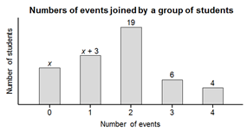
14. The bar chart below shows the distribution of the numbers of events joined by a group of students on the Sport Day. If a student is randomly selected from the group, the probability that the student joins one event is $\frac{6}{25}$.
(a) Find the value of $x$.
(b) If a student is randomly selected from the group,
find the probability that the student joins
more than $2$ events.

15. Three types of drinks, lemon tea, apple juice and orange juice, are packed in cartons and put on a table. The number of cartons of lemon tea is $20$ more than that of apple juice while the number of cartons of orange juice is half of that of lemon tea. If a carton of drink is selected at random, the probability of getting a carton of orange juice is $\frac{2}{9}$. How many cartons of lemon tea are there on the table?

Geometric Probability
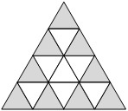
16. The figure shows a dartboard which is made up of $16$ identical equilateral triangles. Philip throws a dart at random and the dart hits the dartboard. Find the probability that the dart hits the shaded region.

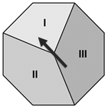
17. The figure shows a lucky wheel in the shape of a regular octagon. Chris spins the lucky wheel once. Find the probabilities that the pointer
(a) stops in region I,
(b) does not stop in region II.

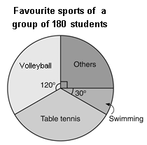
18. The pie chart shows the distribution of the favourite sports of a group of $180$ students. If a student is chosen from the group at random, find the probabilities that his/her favourite sport is
(a) swimming or volleyball,
(b) table tennis.

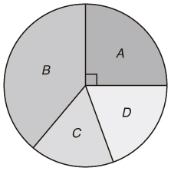
19. The figure shows a circular dartboard. The areas of the $3$ sectors$B, C$ and $D$ are in the ratio $2 : 1 : 1$. If a dart is thrown at random and hits the dartboard, find the probability that the dart hits the sector $C$.

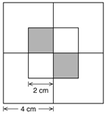
20. As shown in the figure, a dartboard is formed by $4$ squares each of side $4 cm$. Another $4$ squares each of side $2 cm$ are drawn at the centre of the dartboard. If a dart is thrown at random and hits the dartboard, find the probability that it hits one of the shaded regions.

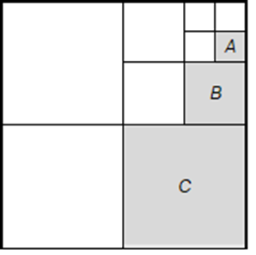
21. As shown in the figure, a dartboard is formed by $4$ squares each of side $4 cm$. Another $4$ squares each of side $2 cm$ are drawn at the centre of the dartboard. If a dart is thrown at random and hits the dartboard, find the probability that it hits one of the shaded regions.

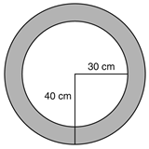
22. The dartboard shown in the figure is made up of two concentric circles of radii $30 cm$ and $40 cm$ respectively. Kenny throws a dart at random and the dart hits the dartboard. Find the probability that the dart hits the shaded region.

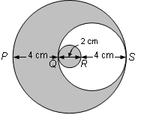
23. The figure shows a dartboard with a pattern formed by $3$ different sizes of circles. $PS, QR$ and $QS$ are the diameters of the circles. Mable throws a dart at random and the dart hits the dartboard. Find the probability that the dart hits the shaded region.

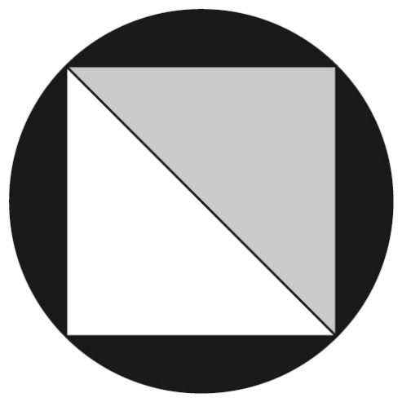
24. The figure shows a circular dartboard of diameter $40 cm$. Two congruent triangles are drawn to form a square inscribed in the dartboard. If a dart is thrown at random and hits the dartboard, find the probability that it hits the grey region. (Express your answer in terms of $π$.)

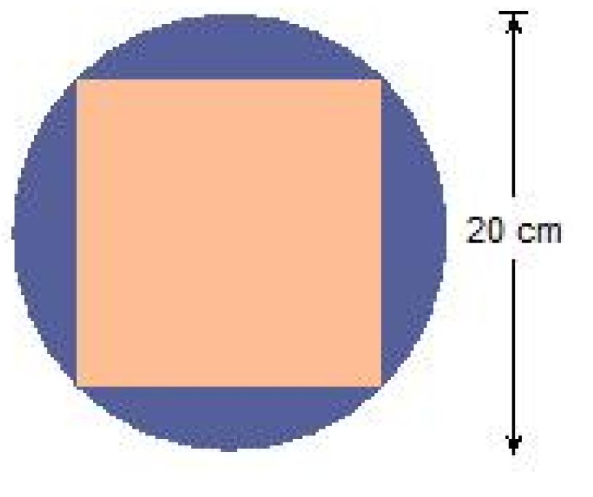
25. A circular dartboard with the diameter of $20 cm$ is shown with a square inscribed in it. Suppose a dart hits a point randomly on the circular dartboard without hitting any boundaries, find the probability that it hits the square region. (Express your answer in terms of $π$.)

